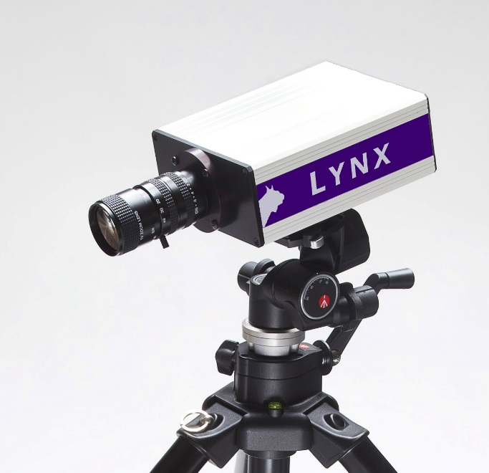EtherLynx Vision Color Photo Finish Camera with EasyAlign™ Mode
EtherLynx Vision cameras represent the sixth generation of the internationally renowned EtherLynx series. First introduced in 1996, EtherLynx cameras quickly became the gold standard in photofinish, and the Lynx tradition of innovation continues to this day. The EtherLynx Vision seamlessly blends ease-of-use features, with cutting-edge innovation, such as the patent-pending LuxBoost feature for amplifying available light.
All Vision cameras communicate with the timing computers running FinishLynx software using standard 10/100/1000 Mbps 802.3 Ethernet topology, with Power-over-Ethernet (PoE) functionality.
 | EasyAlign - Full-frame video mode makes camera alignment easier than ever. |  |  | Power-Over-Ethernet - All Vision cameras can draw power via the Ethernet cable.
 | Full-Color - All Vision cameras come standard with the ability to capture color images. |  |  | Gigabit Transfers - The first EtherLynx camera to allow for Gigabit Ethernet transfers (1,000 Mbps).
 | Silent Operation - The Vision runs silently thanks to reduced power consumption and no fans. |  |  | Advanced Power Control - New power controls ensure the best power source in each situation.
 | Backwards Compatible - The Vision is compatible with all Lynx cameras made since 1996. |  |  | Onboard Level [Upgrade] - Monitor the camera's level and orientation directly from FinishLynx.
 | LuxBoost™ [Upgrade] - Amplifies available light for better race images in low-light conditions. |  |  | Electronic Filter Control [Upgrade] - Users can enable/disable low-light filters from FinishLynx.
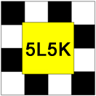 | High-Resolution [Upgrade] – Provides captures up to 2,000 fps with up to 1,280 pixels of height. |  |  | Internal Battery Backup [Upgrade] - Battery pack allows the camera to withstand power loss.

EasyAlign 2-D Video Camera Alignment
EasyAlign™ gives you a clear full-frame live video view of your finish line area allowing you to align the camera quickly and accurately.
Position your camera, align it precisely on the finish line, and then switch to full line-scan photo finish mode.
EasyAlign!
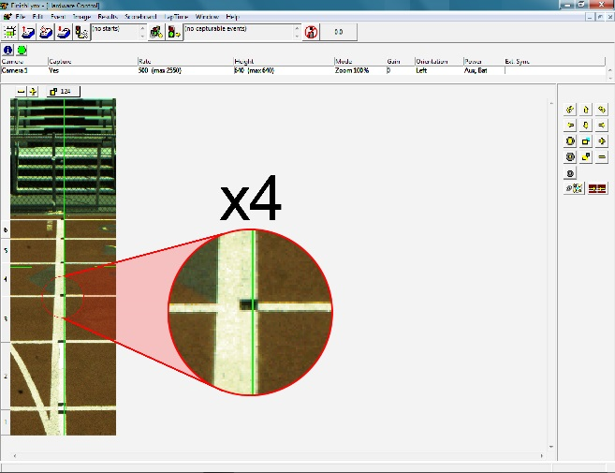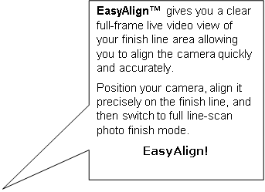EtherLynx Vision cameras offer EasyAlign full-frame video alignment mode. EasyAlign displays a live, full-frame video preview of the camera's field-of-view on your computer screen. The 2-D preview also overlays two thin lines (vertical and horizontal) so the camera can be adjusted visually to ensure precise alignment on the finish line. Once aligned, just switch the camera back to 1-D capture mode for accurate, photo-finish results images.
EasyAlign™ gives you a clear full-frame live video view of your finish line area allowing you to align the camera quickly and accurately.
Position your camera, align it precisely on the finish line, and then switch to full line-scan photo finish mode.
EasyAlign!
With traditional 1-D align mode still available at the click of an icon (to confirm precision alignment) this new 2-D video mode makes it extremely fast and easy to align the camera for accurate results.

Vision Hardware Specifications
Item | Specification
Acquisition Rate | 100 – 1,000 frames per second; 2,000 with High-Resolution option
Pixels (vertical) | 640; 1280 with High Resolution Option
Distance Camera to Computer | 100m Cat 5/6, 2,000m Fiber Optic (with converter)
PC-connection | 10/100/1000Mbit/s 802.3 Ethernet Topology
#colors/pixel | Up to 21bit – 2 million colors (user adjustable)
Sensor Type | CMOS Array
Vertical Pixel Adjustment | Continuously adjustable
Frame Rate Adjustment | Continuously Adjustable
Time Base | 1 Part Per Million (.001s per 16.7 min) - Temp. Compensating
Lens Mount | CS Mount (C-Mount with adaptor)
Camera Alignment Aids | EasyAlign ™ full video image preview
Remote Lens Option | Yes
Remote Alignment Option | Yes
Light Sensitivity | High – Extreme low-light capability with optional LuxBoost™
Switchable IR Filter | Optional - Electronically Controlled 2 stage
Digital Zoom | Optional 2x
Gamma Control | Software
Image Compression | Real-time Lossless
Built-In Battery Backup | Optional
Start Signal Options | - Manual Start  - Normally Open wired sensor/switch closure  - Normally Closed wired sensor/switch closure  - Optional RadioLynx wireless start
Power Input | POE, internal rechargeable batteries, 100-240 VAC with Adaptor, or optional 12v DC input
Operating Temperature | 0° - 60°C
Control multiple cameras from 1 computer | Yes
Mix and Match Camera Models | Yes
Auto-Iris (in addition to Auto-Gain) | Yes
"Hot-swap" instant replacement guarantee | Yes. Applies to in-warranty cameras
Approvals | UL and CE
Camera Body Dimensions | 15.7cm x 7.5cm x 15.5cm
Camera Body Weight (Excluding Lens) | 1.4Kg

FinishLynx Software Features

- Selectable User Interface Language
- Evaluate image while race still in progress
- Allows multiple events to be active simultaneously
- Apply missed starts
- Interface to Meet Manager
- Optional Automatic Capture capability
- Optional Software Photocell function
- User Configurable Screen Layout
- Optional IP-network connection to serial devices
- User-scriptable scoreboard interface
- Optional Interface to RFID transponders/pushbutton timers for split timing

